MA-102 Project Report

Digital Image Processing

Arik Pamnani (15110032) | Meet Gandhi (15110049)

Shivdutt Sharma (15110125) | Ravi Shrimal (15110102)

Abstract – In the project, we have first modelled the camera. A camera matrix defines how 3D world is projected onto a 2D image. An image can be mathematically represented as a matrix. Many transformations such as blurring, rotation can be done on an image. Face Detection algorithm is also explained along with its linkage to Face Recognization.

1. Camera Model – A camera matrix is a 3X4 matrix which maps 3D points in world to 2D points in an image. A 3D point is mapped onto the image plane using the camera model given by the matrix equation –

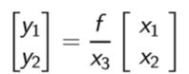

The 3D coordinates are expressed in a homogenous representation, the equation ﬁnally becomes –

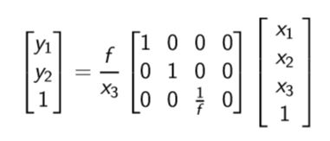

The following is the 3X4 matrix called the camera matrix –

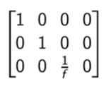

1. Blurring an image – Given a kernel and a part of an image (they must be of the same order), convolution is deﬁned as multiplying entries which are located at the same position in the two matrices and adding. We take a 7X7 averaging filter and convolve it with an image to blur it.

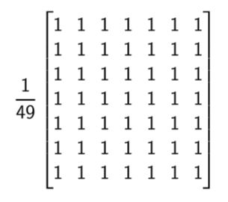

1. Rotation of an image – A 2D image is a function of two variables, f(x, y) where x and y are coordinates in space. Therefore, every pixel of the image can be picturized as lying on the euclidean plane. The following is the rotation matrix which rotates each point on the image in anti - clockwise direction through an angle θ about the origin.

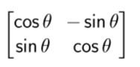

1. Eigen faces -
2. Face Detection Algorithm

* Various Methods and Algorithms used for Face Detection:

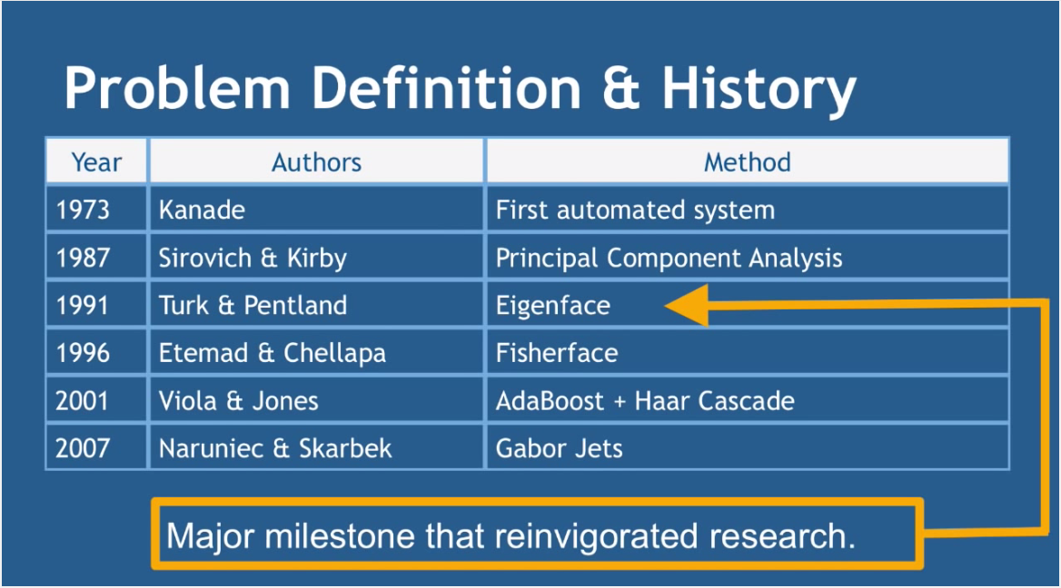

* Codes and Concepts:

1) How computers detect faces or separate other things from human faces?

- By Skin Colour (Colour Detection).

- Motion(Blinking of Eyes).

- Head shape and other unique features of the face.

- All of the above combined.

Most of the modern algorithms for face detection are appearance based rather then learning based.

Modern face detection algorithms are mostly based on Viola Jones object detection frame work which is based on Haar Cascades.

2) Haar Cascade is a collection of Haar like features included altogether to form a classifier.

Haar like features:

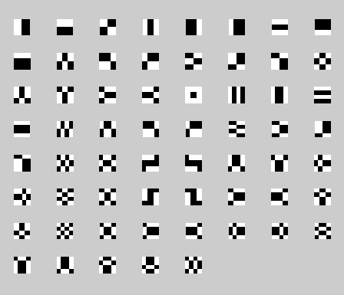

3) How Does Haar-like feature function?

- Fix a scale for Haar like feature (For example: 24 X 24 pixels).

- Starting from the topmost left, slide the Haar-like feature across the whole image.

-Calculate the average pixel values in white and black area of the Haar- cascade.

- If the difference of these values is greater than some threshold, the Haar-like feature matches with the portion of the image Haar-like feature is acted upon.

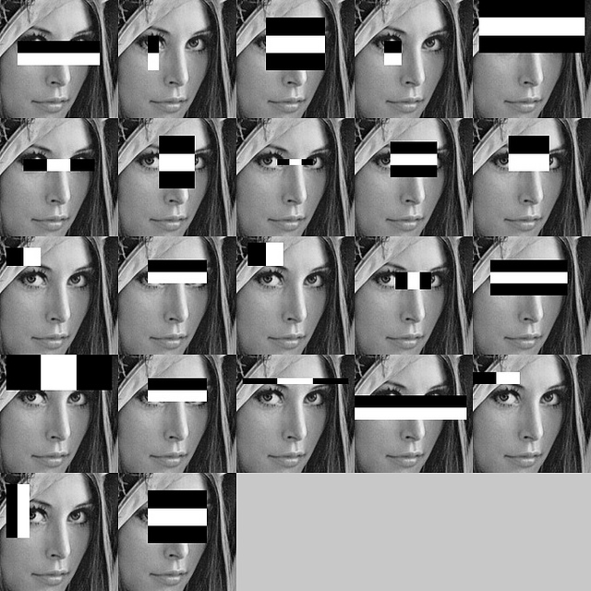

4) Integral Image- A technique to compute the sum of pixels in a given area

Let the computed pixel values obtained by acting the convoluted kernel on an area of an input image be:

Summed-Area Table can be computed by adding all the pixel values which are to the left and also up of the given pixel.

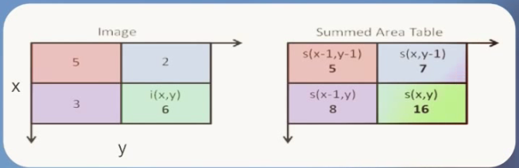

As a result, Integral Image computation allows to calculate the sum of pixels in a given rectangle by only knowing the pixel values at the corners of the rectangle.

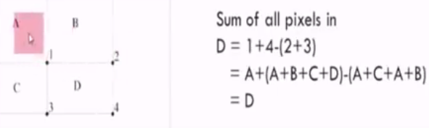

5) Role of Adaboost

Adaboost is a machine learning algorithm that eliminates the redundant features and finds only the best features which can describe the face among 160,000+ features.

After these features are found, a linear combination of these features is used to decide whether a window or a photograph has a face or not.These features are known as Weak classifiers.

Adaboost forms a Strong classifier which is a linear combination of weak classifiers.

Negative value of weighted constant means that the image possesses the opposite feature to that of the Haar-like feature, to some extent which is decided by its magnitude.

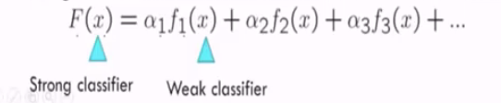

6) Cascading

Cascade classifier is made up of stages. Each stage consists of strong classifiers which is the collection of the most covariant features.

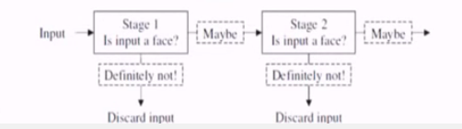

7) Applications

Attendance System

Traffic Regulation at 4 Way crossing by counting the number of people through Face Detection and depending on it controlling the green signal